**Earthquake Proof Buildings** Name: ______________ Due: _____

Earthquakes alone don't kill people; collapsed buildings do. In Chile, an 8.8 Magnitude earthquake in March 2010 killed more than 700 people. On January 12, 2010 a less powerful earthquake, one measuring 7.0 Magnitude, killed more than 200,000 in Haiti.

The difference in those death tolls comes from building construction and technology. In Haiti, buildings were constructed quickly and cheaply. Chile, a richer and more industrialized nation, adheres to more stringent building codes.

Ways to Earthquake proof Buildings ---- 3 main methods.

1. Making Buildings Stronger. This can be done by using materials that are strong yet flexible. Also by putting the materials together in such a way that the buildings framework is strong yet flexible.

|  |  |
| --- | --- |
| Before Earthquake | During Earthquake |
| https://mceer.buffalo.edu/infoservice/images/ReferenceSources/as1.gif | https://mceer.buffalo.edu/infoservice/images/ReferenceSources/as3.gif |

1. Base Isolation. By making buildings more flexible, so they sway and slide above the shaking ground rather than crumbling.

Engineers have constructed skyscrapers that float on systems of ball bearings, springs and padded cylinders. They don't sit directly on the ground, so skyscrapers are protected from some earthquake shocks. In the event of a major earthquake, they sway up to a few feet. These buildings also have a space left around them so that if they sway they do not crash into other buildings.

1. 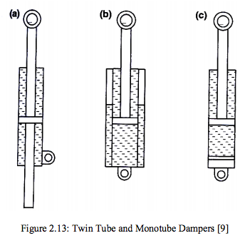Dampers. These help slow down the movement of the building once the earthquake hits. 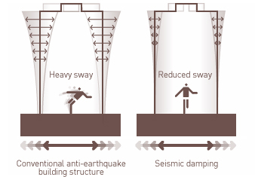 Some of dampers are like pistons that slow the wave like motion of the building down.

Other dampers work by having large masses (called tuned mass dampers) that move in the opposite direction to the earthquake movement, slowing the movement down.

Questions

1. In the diagram below

Describe the design problem with the buildings shown?

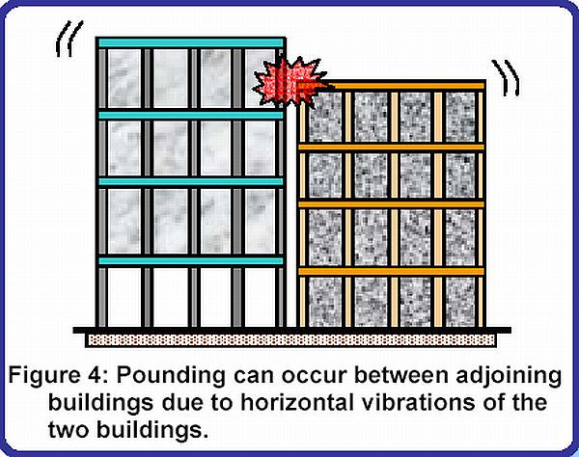

(3 marks)

* _______________________________________________________________________

_______________________________________________________________________

_______________________________________________________________________

* _______________________________________________________________________

_______________________________________________________________________

_______________________________________________________________________

* _______________________________________________________________________

_______________________________________________________________________

_______________________________________________________________________

1. Look at the diagrams below. What does the building frame on the right have that makes it more earthquake proof than the building on the left?

[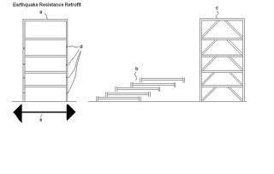](http://3.bp.blogspot.com/_5rZaZCxxpwA/S2RPC-VtjaI/AAAAAAAAATc/Zxif9n2iJ4A/s1600-h/EarthquakeStruts.JPG) (3 marks)

_______________________________________________________________________

_______________________________________________________________________

_______________________________________________________________________

_______________________________________________________________________

_______________________________________________________________________

_______________________________________________________________________

_______________________________________________________________________

1. Look at the diagram below. What type of earthquake proofing does the building on the left have?
2. Describe 2 advantages of this construction.

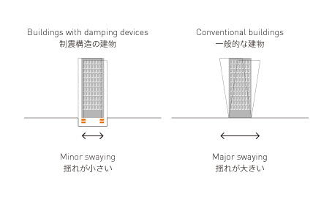(3 marks)

_______________________________________________________________________

_______________________________________________________________________

_______________________________________________________________________

_______________________________________________________________________

_______________________________________________________________________

_______________________________________________________________________

_______________________________________________________________________

1. Look at the picture of the house.

This house was damaged by an Earthquake in San Francisco.

Describe why you think it was so badly damaged?

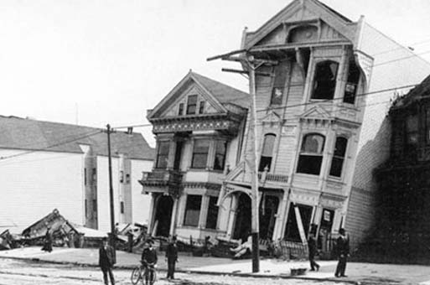

(4 marks)

_______________________________________________________________________

_______________________________________________________________________

_______________________________________________________________________

_______________________________________________________________________

_______________________________________________________________________

_______________________________________________________________________

_______________________________________________________________________

_______________________________________________________________________

_______________________________________________________________________

_______________________________________________________________________

_______________________________________________________________________

_______________________________________________________________________

_______________________________________________________________________

_______________________________________________________________________

_______________________________________________________________________

_______________________________________________________________________

_______________________________________________________________________

1. This is the Taipei Tower in Taiwan. It is 508m tall. Designing a building this large presented unique challenges because Taiwan is subject to typhoons and earthquakes.

To counter movement, an 800-metric tonne, spherical steel ball is located on level 88.

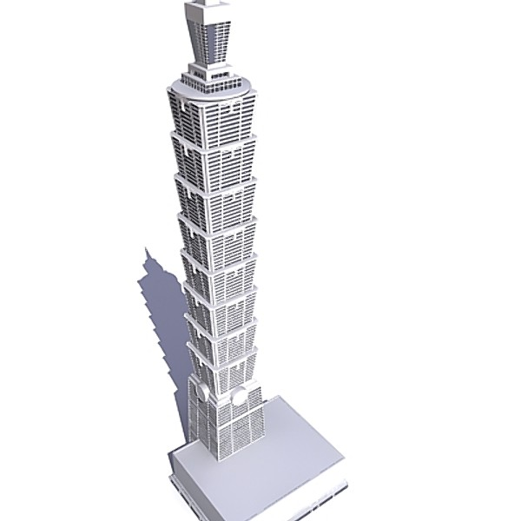

What is this method of earthquake proofing called? (1 mark)

_______________________________________________________________________

_______________________________________________________________________

How does it work? (3 marks)

_______________________________________________________________________

_______________________________________________________________________

_______________________________________________________________________

_______________________________________________________________________

_______________________________________________________________________

_______________________________________________________________________

_______________________________________________________________________

What advantages does it give to the Taipei Tower? (3 marks)

_______________________________________________________________________

_______________________________________________________________________

_______________________________________________________________________

_______________________________________________________________________

_______________________________________________________________________

_______________________________________________________________________

Total Marks: _____ / 20